Controls System Lab 5 Colin Roskos

Summary:

The study of first and second order systems using MATLAB. We studied a first order system, an RC circuit with a step response and varying R and C values, and determined its steady state. We again created a spring-dampener system and studied this second order system.

Conclusion:

For exercise 1, we concluded that the steady state value for both systems (a and b) are the same, and that the tau calculated is that expected.

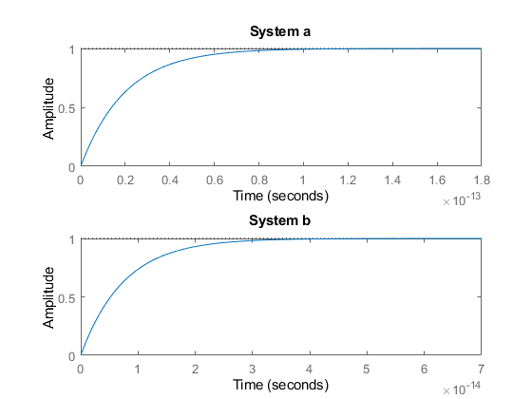

The table for Exercise 2 is as follows:

|  |  |  |  |  |  |
| --- | --- | --- | --- | --- | --- |
| ζ | Rise Time | Peak Time | % Overshoot | Settling Time | Steady State Value |
| 0.1 | 1.1272 | 3.1416 | 72.9% | 40 | 1 |
| 0.4 | 1.4652 | 3.4539 | 25.4% | 10 | 1 |
| 0.7 | 2.1268 | 4.4078 | 4.6% | 5.714 | 1 |
| 1.0 | 3.3579 | 9.7900 | 0.0% | 4 | 1 |
| 2.0 | 8.2308 | 27.3269 | 0.0% | 2 | 1 |

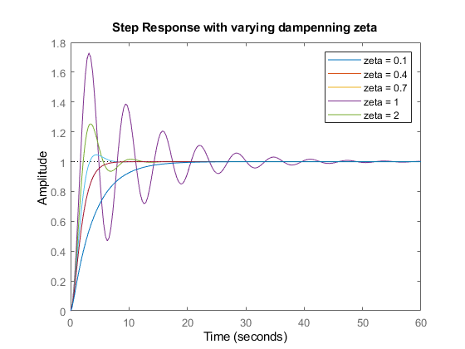

Code and Results:

Ex1:

%% Exercise 1

% RC Circuit

R_a = 2*10^3;

C_a = .01 * 10^-15;

tau_a = R_a*C_a;

T_a = tf([1], [tau_a 1])

R_b = 2.5*10^3;

C_b = .003 * 10^-15;

tau_b = R_b*C_b;

T_b = tf([1], [tau_b 1])

subplot(2,1,1);

step(T_a);

title("System a");

subplot(2,1,2);

step(T_b);

title("System b");

% Unit Step Response

%

% T_a =

%

% 1

% --------------

% s(2e-14 s + 1)

%

%

% T_b =

%

% 1

% ----------------

% s(7.5e-15 s + 1)

%

Ex2:

%% Exercise 2

% Spring-Mass System

% M = 1;

% B = 1;

% K = 1;

%

% T_2 = tf([1], [M B K]);

% wn = sqrt(K/M);

% ze = B/(2*M*wn);

ze_table = [.1 .4 .7 1. 2.];

wn = 1;

leg = []

t = 0 : .01 : 12;

for i=1:5

ze = ze_table(i);

T = tf([wn^2], [1 2*ze*wn wn^2])

step(T); hold on;

leg = [leg strcat("zeta = ", string(ze))];

S1 = stepinfo(T, "SettlingTimeThreshold", .02);

S2 = stepinfo(T, 'RiseTimeThreshold',[0.1 0.9]);

fprintf("\nRise Time (Z = %.1f) : %6.4f\n", ze, S2.RiseTime);

fprintf("Peak Time (Z = %.1f) : %6.4f\n", ze, S2.PeakTime);

fprintf("Overshoot (Z = %.1f) : %3.1f%%\n", ze, S2.Overshoot);

fprintf("Settling Time (Z = %.1f) : %6.4f\n", ze, S2.SettlingTime);

SteadyState = tzw_response(1000, ze, wn);

SteadyState = SteadyState(end);

fprintf("Steady State (Z = %.1f) : %6.4f\n", ze, SteadyState);

settling_time = 4/(ze * wn);

fprintf("Calculated Settling Time (Z = %.1f) : %6.4f\n\n", ze, settling_time);

end

legend(leg);

title("Step Response with varying dampenning zeta")